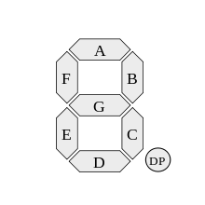0 G  
1 F  
2 E  
3 D  
4 C  
5 B  
6 A  
7 point